# Eisha Tir Raazia

17k-3730

Sec C

OOAD Lab Assignment1

Miss Javeria Farooq.

# Q1:

# Use-Case Diagram:

Use Case: **Hospitalized Patient**

Actors: Doctor (initiator)

Type: Primary and essential

Description: Doctor can visit hospitalized in patients.

Use Case: **Schedule Appointment**

Actors: Out Patient (initiator), Receptionist

Type: Primary and essential

Description: Out patient can request for scheduled an appointment with the doctor. Later receptionist will book an appointment of an out patient with doctor according to the time schedule.

Use Case: **Deliver Medicine**

Actors: Pharmacy (initiator)

Type: Primary and essential

Description: Pharmacy can deliver the medicine for the customers. Customer can be a normal customer or a patient.

Use Case: **Receive Medicine**

Actors: Patient, Customer both are initiator

Type: Primary and essential

Description: Patient and customer can receive the medicine from the pharmacy.

Use Case: **Medicine**

Actors: Patient, Customer are initiator, Pharmacy

Type: Primary and essential

Description: Patient and customer are to be allowed to purchase the medicine from the pharmacy as they ready to sell it.

# Domain Model:

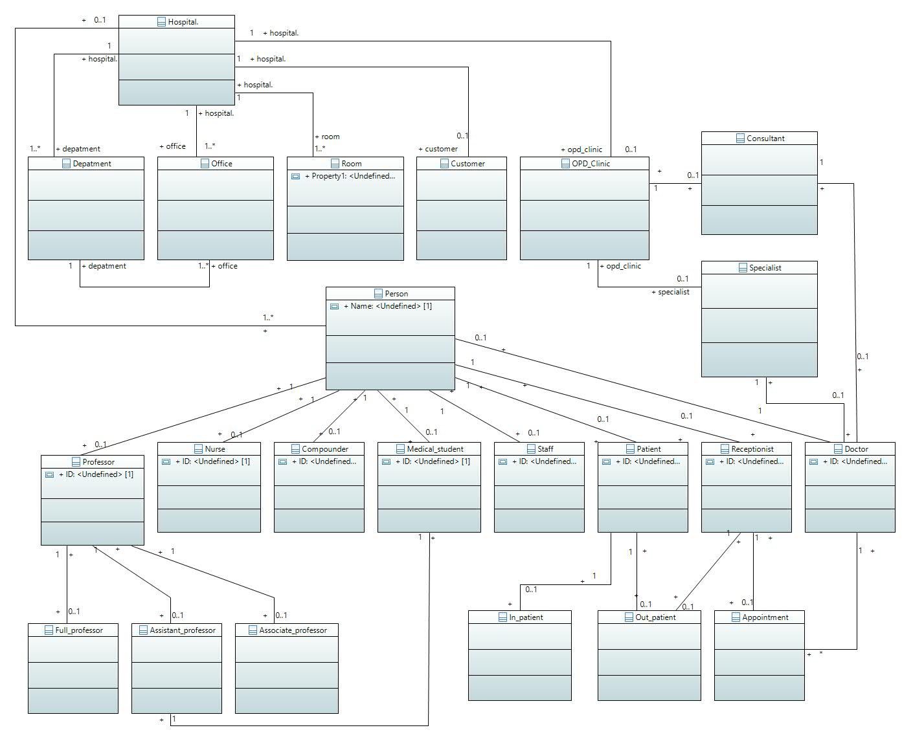

# Class Diagram:

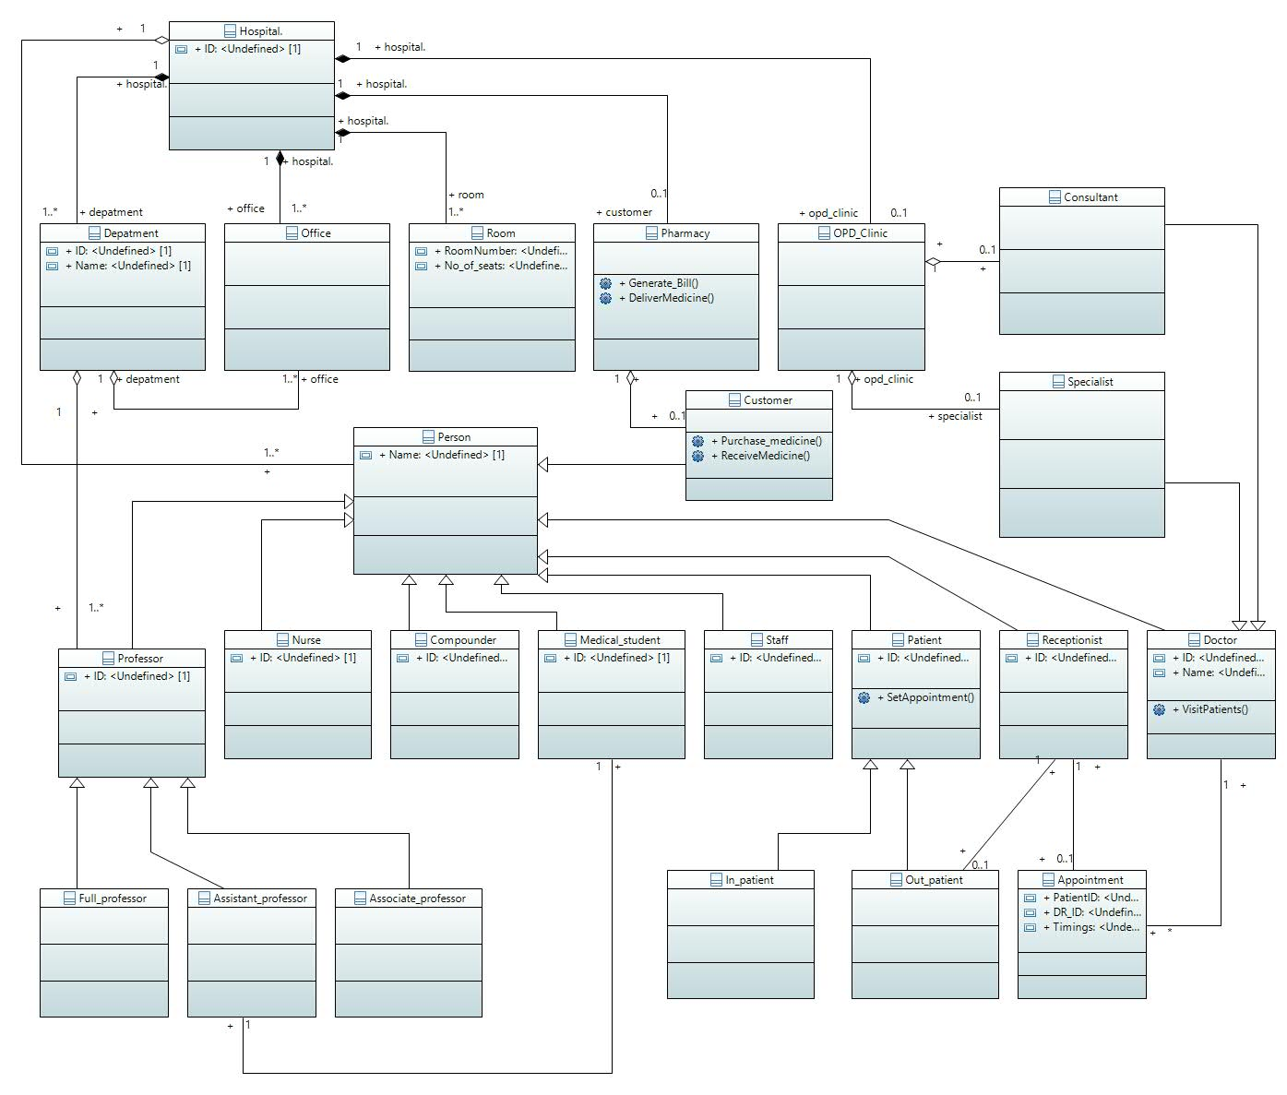

# Use Case Diagram:

